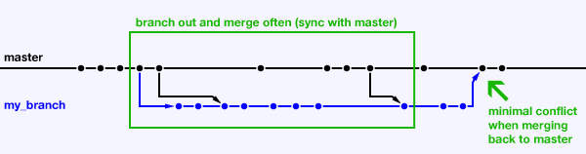

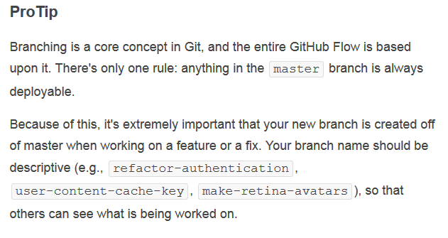

**Forking Workflow**

The Forking Workflow is fundamentally different than the other workflows discussed in this tutorial. Instead of using a single server-side repository to act as the “central” codebase, it gives *every* developer a server-side repository. This means that each contributor has not one, but two Git repositories: a private local one and a public server-side one.

The main advantage of the Forking Workflow is that contributions can be integrated without the need for everybody to push to a single central repository. Developers push to *their own* server-side repositories, and only the project maintainer can push to the official repository. This allows the maintainer to accept commits from any developer without giving them write access to the official codebase.

The result is a distributed workflow that provides a flexible way for large, organic teams (including untrusted third-parties) to collaborate securely. This also makes it an ideal workflow for open source projects.